TUẦN 4

Pre: 23/9/2023

Teaching: 25/09/23
PERIOD 10. UNIT 2. HEALTH
Lesson 1. New words + Reading ( p. 12 )

I. Objectives
By the end of the lesson, Ss will be able to:
1. Knowledge
- talk about a healthy and unhealthy lifestyle, using phrases: get some sleep, eat fruits and vegetables, eat fast food, drink soda, healthy, unhealthy.
- practice reading and understanding general and specific information about Toby and Lisa’s healthy living class survey.
- use indefinite quantifiers.
2. Ability
- improve communication, collaboration, analytical and critical thinking skills.
3. Qualities
- lead a healthy lifestyle and ditch bad ones.
II. Teaching equipment and materials
- Materials: books, hand out, worksheet, flashcards.
- Equipment: Projector, computer, loudspeaker.
III. Teaching procedure
+ Class organization
Date | Class | Attendance | Absence
 | 7A
 | 7B
Activity 1: Start
a. Aims: Introduce the new lesson and set the scene for Ss to acquire new language; get students' attention at the beginning of the class by enjoyable and short activities as well as to engage them in the follow-up steps.
b. Content: Introducing some verb phrases and adjectives about lifestyle.
c. Output: Ss have general ideas about the topic of the new lesson: “health”.
d. Form:
Teacher's and Students’ activities | Main contents
+ Game: CROSSWORD  1. Transferring the learning task:  - Explain the rules of the game.  - Design the game “Crossword Puzzle” with words and pictures about food and drink.  2. Doing the task:  - Let Ss play the game, encourage Ss to guess the key word.  - If any S can give the correct key word, T hasn’t confirmed yet, the game will be continued until the keyword is opened (to check whether his/her answer is correct or not and to let other Ss take part in the game eagerly).  3. Reporting the task result and discuss:  - Give a small gift to the Ss who is the fastest to give the correct key word.  - Ask Ss an extra question: Which food / drink is good / not good for your health?  4. Giving the remarks to their doing the task:  - Give feedback and lead to the new lesson. | 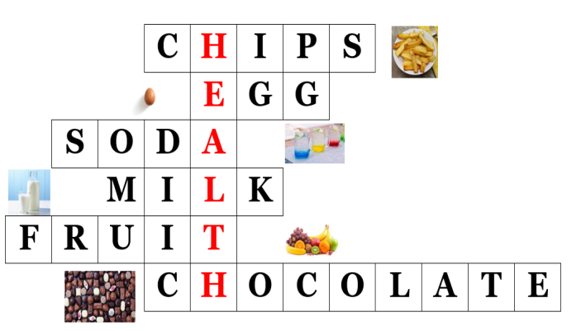  Keyword: HEALTH
Activity 2: Form the new knowledge:
+ Pre-Reading
a. Aims: Ss know some verb phrases about lifestyle.
b. Content:
- Vocabulary study (get some sleep, eat fruits and vegetables, eat fast food, drink soda, healthy, unhealthy).
- Speaking: Discuss which things are healthy and unhealthy.
c. Output: Ss know how to pronounce the new words correctly and use them in appropriate situations.
d. Form:
Task a. Match the words and phrases with the pictures. Listen and repeat.  + Matching (If the teacher has used part a. for the Warm-up activity)  1. Transfering the learning task:  - Have Ss review the words they have learned in the warm-up activity by looking at the pictures and filling in the blanks, (T uses different pictures from those in the textbook).  2. Doing the task:  - Call Ss to give answers (read or write).  - Check answers as a whole class.  3. Reporting the task result and discuss:  - Call some Ss to read the words again.  4. Giving the remarks to their doing the task:  - Correct Ss’ pronunciation if necessary.  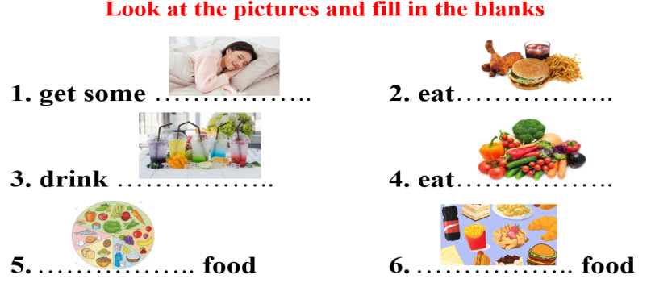  Task b. Discuss which things are healthy and unhealthy.  1. Transfering the learning task:  - Have Ss discuss in pairs which things are healthy and unhealthy.  2. Doing the task:  - Have Ss share their ideas in front of the class.  - Give feedback and evaluation.  3. Reporting the task result and discuss:  - Have Ss give more activities related to lifestyle which are divided into 2 groups: healthy and unhealthy.  4. Giving the remarks to their doing the task:  - Give feedback and evaluation. | Answer keys  1. get some sleep  2. eat fast food  3. drink soda  4. eat vegetables  5. healthy food  6. unhealthy food  Suggested answers  Healthy: get some sleep, east fruit and vegetables  Unhealthy: eat fast food, drink soda
Activity 3. Practice
+ While - Reading
a. Aims: Students can develop their reading skill.
b. Content: Reading Toby and Lisa’s class report and choosing the correct answer, then reading Toby and Lisa’s Healthy Living Class Survey and circling the correct answer.
c. Output: Students can read and understand general and specific information about a healthy living class survey.
d. Form:
Task a. Read Toby and Lisa’s class report and circle the correct answer  1.Transfering the learning task:  - Use DCR to show the task. Ask Ss to read two options and find out keywords.  2. Doing the task:  - Have Ss read the class report individually.  - Have Ss circle the correct answers.  3. Reporting the task result and discuss:  - Have some Ss share their answers with the class (read), explain their answers.  4. Giving the remarks to their doing the task:  - Give feedback and correct Ss’ answers if necessary.  Task b. Now, read and circle the correct answers.  1. Transfering the learning task:  - Use DCR to show the task. Have Ss read the questions, underline key words and guess the answers.  2. Doing the task:  - Have Ss read the text again and circle the correct answers – underline or highlight the supporting ideas.  3. Reporting the task result and discuss:  - Have Ss check answers with their partners.  - Call Ss to give answers, explain.  4. Giving the remarks to their doing the task:  - Give feedback and evaluation. | Answer keys  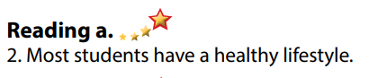  Answer keys  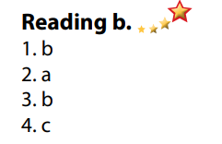
Activity 4. Application
+ Post - Reading
a. Aims: Students can use the vocabulary and ideas from the reading text to develop their speaking skill.
b. Content: Speaking: Do you have a healthy lifestyle? Why / Why not?
c. Output: Students can talk about their own lifestyle and try to lead a healthy lifestyle.
d. Form:
Task c. In pairs: Do you have a healthy lifestyle? Why / Why not?  1. Transfering the learning task:  - Have Students work in pairs to talk about their lifestyle and decide whether it is healthy or not.  2. Doing the task:  - Call some Ss to share their ideas with the whole class.  3. Reporting the task result and discuss:  - Give feedback and evaluation.  4. Giving the remarks to their doing the task:  - For more practice, have Ss play a game with DHA.  * Consolidation:  - Verb phrases about lifestyle: get some sleep, eat fruits and vegetables, eat fast food, drink soda.  - Adjectives: healthy and unhealthy.  * Homework:  - Learn the new words by heart.  - Practice talking about lifestyle.  - Do the exercises in WB: Unit 2 - Lesson 1 - New words + Reading (pages 8,9).  - Do the vocabulary exercise in Tiếng Anh 7 i-Learn Smart World Notebook (page 10).  - Play consolation games in Tiếng Anh 7 i-Learn Smart World DHA App on www.eduhome.com.vn  - Prepare: Lesson 1.2 – Grammar (page 13 – SB). | Ss’ discussion about their lifestyles.
CHUYÊN MÔN TỔ CM GV SOẠN

Trần Văn Dung Mai Thị Hương Mai Thị Hương

