TUẦN 9
Pre: 28/10/2023
Teaching: 30/10/23
PERIOD 25. UNIT 3. MUSIC AND ARTS
LESSON 3. WRITING + SPEAKING ( P.27 )

I. OBJECTIVES
By the end of the lesson, Ss will be able to:
1. Knowledge
- study format of writing a movie description.
- talk about their favorite movies.
- write a short description of a movie they like.
2. Ability
- improve communication, collaboration, writing and critical thinking skills.
3. Qualities
- love movies.
II. Teaching equipment and materials
- Materials: books, hand out, worksheet, flashcards.
- Equipment: Projector, computer, loudspeaker.
III. Teaching procedure
+ Class organization
Date | Class | Attendance | Absence
 | 7A
 | 7B
+ New lesson
Activity 1: Start:
a. Aims: Introduce the new lesson and set the scene for Ss to acquire new language; get students' attention at the beginning of the class by enjoyable and short activities as well as to engage them in the follow-up steps.
b. Content: Types of films.
c. Output: Ss know some film types that they are going to talk and write about in new the lesson.
d. Form
TEACHER’S AND STUDENTS’ ACTIVITIES | MAIN CONTENTS
Types of films  1.Transfering the learning task:  - Give a list of film types and their equivalent movie names.  2. Doing the task:  - Have Ss look and guess the meaning of these film types.  3. Reporting the task result and discussing:  - Have Ss give answers.  4. Giving the remarks to their doing the task:  - Give feedback and show correct answers.  - Lead to the new lesson.  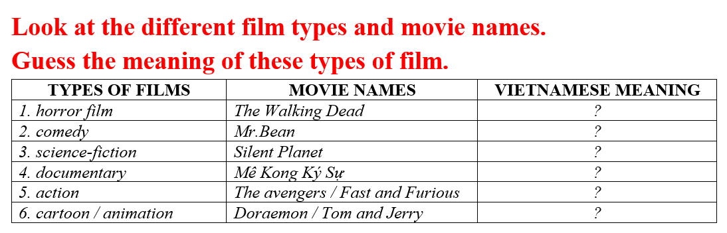 | *Types of films  Answer keys  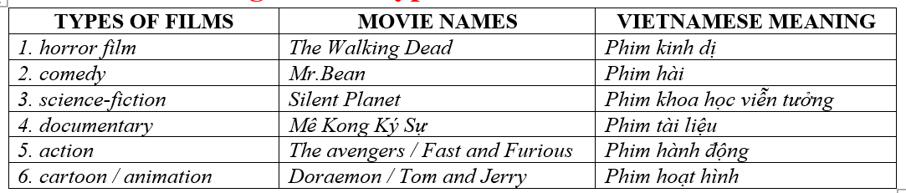
Activity 2: Form the new knowledge
Pre-Writing (Speaking)
a. Aims: Ss prepare for what they are going to write about.
b. Content
- Speaking: You're talking about your favorite movies. In pairs: Ask your partner the following questions.
- Make notes about your favorite movie using the questions.
c. Output: Ss know more vocabularies about kinds of films and apply the language from speaking to their writing.
d. Form
TEACHER’S AND STUDENTS’ ACTIVITIES | MAIN CONTENTS
*Task a.  1.Transfering the learning task  - Divide the class into pairs.  2. Doing the task  - Have students ask and answer using the questions.  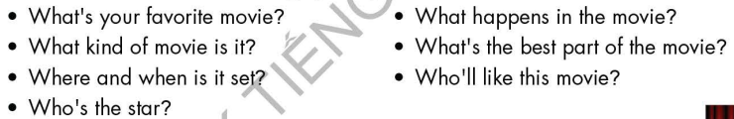  3. Reporting the task result and discussing  Have some students share their ideas with the class.  4. Giving the remarks to their doing the task  - Give feedback and evaluation.  *Task b.  1.Transfering the learning task  - Have students make notes about their favorite movie using the questions  2. Doing the task  - Go round and give help if necessary.  3. Reporting the task result and discussing  - Have some pairs read their answers.  4. Giving the remarks to their doing the task  - Give feedback and evaluation | *Task a. You're talking about your favorite movies. In pairs: Ask your partner the following questions.  *Task b. Make notes about your favorite movie using the questions
Activity 3. Practice
While - Writing
a. Aims: Students can develop their writing skill.
b. Content:
- Read about writing a movie description. Then, read the description of The Dark Knight again and underline the plot summary.
- Reorder the movie description. Use the skill box to help you.
- Write a short description of a movie you like.
c. Output: Students can write a film description, using right format and rich vocabularies.
d. Form:
TEACHER’S AND STUDENTS’ ACTIVITIES | MAIN CONTENTS
*Task a.  1.Transfering the learning task  -Briefly explain the Writing skill box.  - Have Ss read the description of The Dark Knight again (page 26), then underline the plot summary.  2. Doing the task  - Have Ss check their answers with a partner.  - Call Ss to give answers.  3. Reporting the task result and discussing  - Check answer as a whole class using DCR.  4. Giving the remarks to their doing the task  - Give feedback and evaluation  *Task b  1.Transfering the learning task  - Have Ss read the sentences, then reorder the movie description.  2. Doing the task  - Have Ss check their answers with a partner.  - Call Ss to give answers.  3. Reporting the task result and discussing  - Check answer as a whole class using DCR.  4. Giving the remarks to their doing the task  - Give feedback and evaluation  *Let’s Write: Now, write a short description of a movie you like. Use the feedback form to help you  - Draw Ss’ attention to the feedback form.  - Have Ss use their notes in speaking part and the instruction in the Writing box to write a short description of a movie they like.  - Go round, observe and give help if necessary.  - Have some Ss write their letter on the board. | *Task a. Read about writing a movie description. Then, read the description of The Dark Knight again (page 26) and underline the plot summary  Answer keys  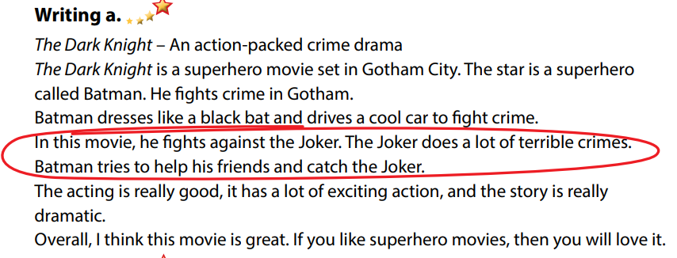  * Task b. Reorder the movie description. Use the skill box to help you.  Answer keys  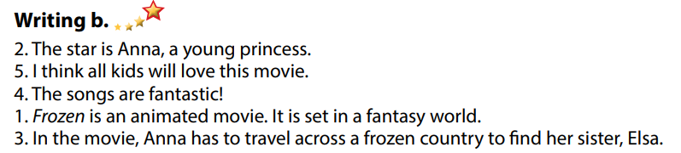  * Write.  Suggested writing  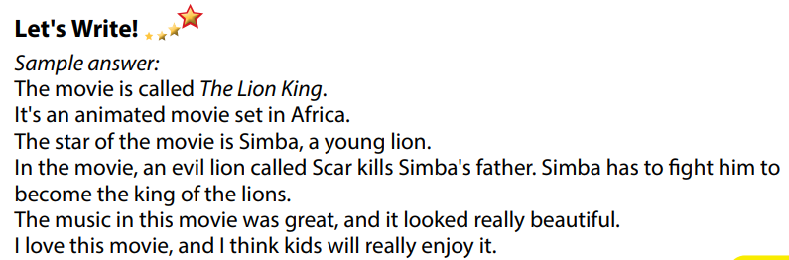
+ Activity 4. Application
Post - Writing
a. Aims: Help Ss realize their mistakes in writing and correct them.
b. Content: Correcting Ss’ writings.
c. Output: Students know whether their writings follow the model and use the correct structures and language, whether their writings are interesting and understandable or not.
d. Form
TEACHER’S AND STUDENTS’ ACTIVITIES | MAIN CONTENTS
Conversation skill  - Give feedback, correct Ss’ mistakes.  - Use the feedback form to give evaluation. Focus on:  + the format, the structures.  + the understandability.  + the coherence and cohesion.  * Consolidation  * Homework  - Remember how to write a movie description.  - Finish the writing part.  - Do the exercises in WB: Lesson 3 – Writing (page 19).  - Complete the grammar notes in Tiếng Anh 7 i-Learn Smart World Notebook (page 21). | - Look, listen and correct mistakes.
CHUYÊN MÔN TỔ CM GV SOẠN

Trần Văn Dung Mai Thị Hương Mai Thị Hương

